

**Gulf Aluminium Rolling Mill B.S.C. (closed)**

**ICT Department**

**Time & Attendance System**

***Software Requirement Specifications***

***For Upgrade***

Document Revision History:

|  |  |  |  |
| --- | --- | --- | --- |
| **Version** | **Date** | **Remarks** | **Author** |
| 1.0 | 03 Mar. 2016 | Draft created | Ervin Brosas |
| 1.0 | 14 Mar. 2016 | Reviewed | Husni Ameen |
| 1.0 | 14 Mar. 2016 | Added Use Case Diagram | Ervin Brosas |
|  |  |  |  |

Document Approval (Sign-off):

|  |  |  |  |
| --- | --- | --- | --- |
| **Approver Name** | **Position** | **Signature** | **Date** |
| Fahad Albasam | Human Resource Manager |  |  |
| Mohamed Fakhroo | Head of HR |  |  |
|  |  |  |  |
|  |  |  |  |

Table of Contents

INTRODUCTION 4

Purpose 4

Audience 4

OVERALL DESCRIPTION 4

Project Perspective 4

System Interface 5

User Interface 5

Software Interface 5

Hardware Interface 5

Use Case 6

Design Attributes 8

Summary: 8

Constraints 8

Software System Attributes 8

SPECIFIC REQUIREMENTS 9

Functional Requirements 9

Conceptual Site Map 17

System Architecture 18

CHANGE MANAGEMENT PROCESS 19

WEB FORMS 19

# INTRODUCTION

## Purpose

This document delineates the overall description and functional requirements for upgrading the current Time & Attendance System (TAS) to the latest technology platform. Most functionalities available in the old system will remain intact and new functionalities will be incorporated. The user interface (UI) forms will be changed to provide better user interaction.

## Audience

This document is intended for Human Resource Department Stakeholders for their perusal on various functionalities that will be implemented in the Project as well as to identify any additional requirements that will better enhance the system. This is also intended for Software Engineers to provide guidelines in designing the technical specifications of the Project in accordance to the user’s requirements.

# OVERALL DESCRIPTION

## Project Perspective

The current TAS is developed using Iron-speed web development tool. Although Iron-speed tool was helpful in rapid development of TAS application, the maintenance and enhancements to the application was cumbersome due to its limited capabilities.

The Project aims to redesign the entire Time & Attendance System using Microsoft ASP.NET technology, in line with other GARMCO web based systems. The new TAS will consolidate the current isolated mini systems such as the Employee Self Service, Employee Directory, and Fire Team Tracking into one software solution as well as incorporate the enhancements and resolve the reported issues. The Employee Self Service System which is used to view the employee’s swipe, attendance, absences and leave history as well as the leave balances and DIL Entitlements can be integrated into the new system since data is fetch from the same database storage. Same can be applied to the Fire Team Tracking and Employee Directory systems as well.

To summarized, the new TAS will be developed due to the following reasons:

* The old system cannot be maintained since it was developed using Iron Speed 3rd party tool which is no longer supported by GARMCO.
* No source code is available hence any change request that requires code modifications cannot be implemented.
* Several issues, bugs, and system limitations reported by users in some reports and forms are still unresolved since it requires code modification which is not possible.
* Performance is an issue since the system was developed using an old technology.
* The current security setup is not centralized as compared to other AMS .NET systems.
* The system should be upgraded to the latest .NET technology to provide better performance, usability, maintainability and security.
* The current reports should be upgraded to Telerik Report to allow robust design and export to other file formats such as Excel, PDF, CSV, and Rich Text.
* The look and feel of the system should be enhanced in order to provide user-friendly GUIs and better interactions.
* Consolidate different versions of TAS into one solution and integrate other small and new systems such as Employee Self Service, Employee Directory, Fire Team Tracking and Visitor’s Pass Tracking System.

### System Interface

The Project will be integrated with other existing systems such as JDE Enterprise One, GAP, Employee Leave Planner and Plant Swipe Access System. Related data across the systems will be synchronized in real time to maintain data integrity and reliability.

### User Interface

Users will interact with the system through a Graphical User Interface (GUI) forms that will be accessible through the use of an internet browser such as Internet Explorer (IE) or Firefox. The GUI will be divided into 4 main groups which include the following:

1. **User Entry Functions** – consist of UI forms which are accessible to ordinary users, secretaries and clerks.
2. **HR Functions** – consist of UI forms that are used to handle HR related tasks
3. **MIS Functions** – consist of UI forms that will be used by ICT System Administrators to perform system wide changes and other database related tasks
4. **Administration Functions** – consist of UI forms that are used to configure system security and user permissions

### Software Interface

The Project will be developed using Microsoft .NET Framework 4.5, Entity Framework 7, Windows Communication Foundation (WCF), and Telerik RadControls for ASP.NET AJAX.

### Hardware Interface

No hardware interface requirements

## Use Case

The Use Case diagram below shows the different actors that will be involved in using the system. Its main objective is to highlight the functionalities available to each type of user.

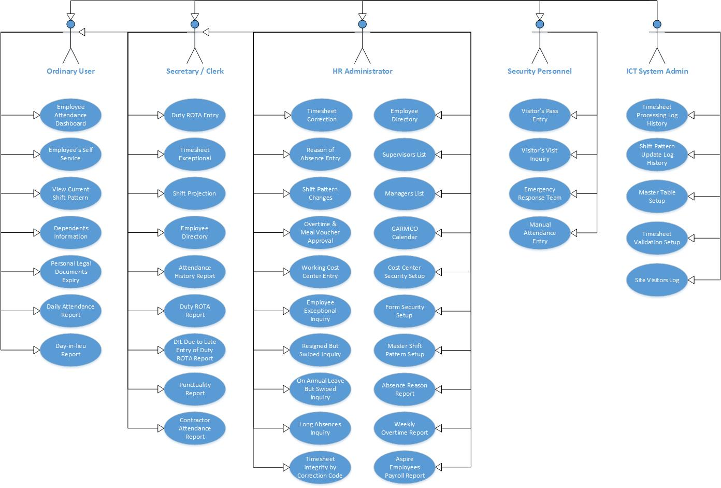 Figure 1: TAS Use Case Diagram

**Actors:**

* **Ordinary User** – refer to any employee in GARMCO who has valid account in Active Directory and is permitted to use the system. Users of this type has access to the following forms and reports:
  1. Employee Attendance Dashboard
  2. Employee Self Service
  3. View Current Shift Pattern
  4. View Dependents Information
  5. Personal Legal Documents Expiry
  6. Daily Attendance Report
  7. Day In Lieu Report
* **Secretary / Clerk** – users of this type have the same access level given to Ordinary Users plus access to other forms and reports that include the following:
  1. Timesheet Exceptional Inquiry
  2. Duty ROTA Entry
  3. Shift Projection
  4. Employee Directory
  5. Attendance History Report
  6. Duty ROTA Report
  7. DIL Due to Late Entry of Duty ROTA Report
  8. Punctuality Report
  9. Contractor Attendance History
* **HR Administrator** – users of this type have the same access level given to Secretaries / Clerks plus access to other forms and reports that include the following:

1. Timesheet Correction
2. Reason of Absence Entry
3. Shift Pattern Changes (Employee, Contractor, Fire Team)
4. Overtime and Meal Voucher Approval Form
5. Working Cost Center Entry
6. Employee Exceptional Inquiry
7. Resigned But Swiped Inquiry
8. On Annual Leave But Swiped Inquiry
9. Long Absences Inquiry
10. Timesheet Integrity by Correction Code Inquiry
11. Employee Directory
12. Cost Center Manager List Inquiry
13. Supervisors List Inquiry
14. GARMCO Calendar Inquiry
15. Cost Center Security Setup
16. Form Security Setup
17. Master Shift Pattern Setup
18. Absence Reason Report
19. Weekly Overtime Report
20. Aspire Employees Payroll Report

* **Security Personnel** – users of this type have the same access level given to Ordinary Users plus access to other forms that include the following:

1. Manual Timesheet Entry
2. Emergency Response Team Inquiry
3. Visitor's Pass Entry
4. Visitors Visit Inquiry

* **ICT System Administrator** – members of this group has full access permissions in all forms and reports available in the system.

## Design Attributes

### Summary:

* The Homepage will consists of a dashboard that will show employee related information such as the following:
  + Swipes History
  + Attendance History
  + Absences History
  + Leave History
  + Leave Balances
  + DIL Entitlements and Usage History
  + Shift Pattern Information
  + Dependents Information
  + Personal Legal Documents
* Links to other AMS systems that are related to the employee attendance will be provided in the Homepage which include the following:
  + Leave Requisition Module
  + DIL Module
  + Employee Leave Planner
  + Plant Swipe Access System
* The GUI (Graphical User Interface) forms will be divided into 4 main groups as follow:
  + User Functions Entry
  + HR Functions
  + MIS Functions
  + Administration Functions
* The system will be designed to provide rich internet experience to end-users.
* The system will follow the best practices in software development using Agile Methodology and Model-View-View-Model (MVVM) design pattern.
* Fine grain security settings will be implemented in the system. The Administrator can customize the user access based on roles and can be applied at the form/report level or functionality wise.

### Constraints

The Project will be developed using Microsoft Visual Studio 2015 development tool. The backend database will use Microsoft SQL Server 2012. The system will be hosted in IIS version 7.x upon deployment.

### Software System Attributes

#### Availability

Any changes implemented in the system will be tested in a separate test server environment before final version will be deployed in the production server. In addition, Stakeholders will be notified through email regarding any major updates implemented so as not to impede with their day-to-day operation. No necessary reinstallation will be done on the user’s side since the system is hosted in a centralize location.

#### Security

To maintain confidentiality of data, Windows Authentication will be used to authenticate users. This will save users in keeping additional accounts.

#### Maintainability

The Project will use the best practices and current trend in software development. The system will be developed using Agile Methodology wherein advancement to software technology can be implemented without impacts in the business requirement.

#### Portability

Portability is one of the premier points of the Project because it will not be dependent on the user’s computer specification but rather rely on the centralized web server.

# SPECIFIC REQUIREMENTS

## Functional Requirements

This Project ensures all users with the following functionalities:

* The system will be developed as a web application using the latest Microsoft .NET technology and other 3rd party tools to provide user-friendly GUIs.
* The system will be hosted in a centralized web server. Users can access it using internet browsers such as Internet Explorer or Firefox. There is no need to install the system on each individual workstations.
* Windows Authentication will be used as a means of authenticating authorized users. This enables Single Sign-On functionality wherein user credential is taken from the Windows login account. No separate login page is required to access the system unless the user has no account in the Active Directory.
* Security will be strictly enforced. Access to various forms and reports available in the system will depend on the type of role assigned to the user.
* All reports available in the system can be exported to other file formats such as Excel, PDF, CSV and RTF.
* The system’s homepage will be a dashboard that will show employee related information such as the swipe history, attendance history, absences history, leave history, leave balances, DIL entitlements, current shift pattern, family dependents information and personal legal documents. Information will be shown on a single screen allowing users to view at a glance all useful information related to his employment at GARMCO.
* Links to other AMS systems which are related to the employee’s attendance will be provided in the homepage to allow interactive communication between various systems. These include the Employee Leave Planner, Annual Leave Requisition, DIL Module, and Plant Swipe Access System.
* The systems’ GUI forms will be divided into 4 main groups which are summarized below. *(Note: The current issues, bugs and limitations reported by users on a particular form or report is highlighted in the Remarks field. This will serve as a reference during development.)*

1. **User Entry Functions** – consist of UI forms accessible to Ordinary Users, Secretaries and Clerks. The following table summarizes the forms that are included in this group as well as its descriptions, limitations and know issue or bug reported by users.

|  |  |  |
| --- | --- | --- |
| Form/Report Name | Description | Remarks |
| 1. Employee Attendance Dashboard | This form is used to check the employee attendance records based on the swipes at the Main Gate/Foil Mill entrances. The swipe time at the Main Gate/Foil Mill entrance is shown on the form as well as the attendance remarks and extension number. | *Current Limitation:*   * No functionality to view the attendance records on previous date. |
| 1. Employee’s Self Service | This form is used to view the employee’s swipe history, absences history, leave history, attendance history, leave balances and DIL entitlements. | *Know Issue/Bug:*   * The Attendance History grid does not display data in proper order when sorted by date.   *Current Limitations:*   * The swipes history display information for the past 9 days only. * No functionality to display information based on date range. |
| 1. Duty ROTA Entry | This form is used to view, add, edit and delete duty ROTA entry for ICT, Purchasing and Engineering departments |  |
| 1. Shift Projection | This form is used to view the projected shift pattern assignment to all employees that belong to the selected cost center for the span of 1 month starting on the specified date. | *Know Issue/Bug:*   * The report crashes when filtering data for Salary Staff employees only.   *Current Limitation:*   * No functionality to filter data by employee no., cost center, and date range. |
| 1. Emergency Response Team Inquiry | This form shows the current on-duty Fire Team members with their respective employee information and contact numbers. |  |
| 1. View Current Shift Pattern | View the shift pattern information of the selected employee | *Current Limitation:*   * No functionality to search for the desired employee when employee no. is not known. |
| 1. View Dependents Information | View the employee’s family dependents information | *New form to be added in the system.* |
| 1. Personal Legal Documents Expiry | View legal documents and its expiration such as CPR, resident permit, etc. | *New form to be added in the system.* |
| 1. Visitor’s Pass Entry | This form will be used by Security Personnel to record information about the entry of visitors to GARMCO premises. | *New form to be added in the system.* |
| 1. Daily Attendance Report | This report shows the attendance record of all Shifter or Salary Staff employees based on the specified date and cost center. | *Know Issue/Bug:*   * The report crashes when filtering data for Salary Staff employees only.   *Current Limitation:*   * No functionality to view attendance records based on date range. |
| 1. Employee Attendance History Report | This report shows the attendance history of an employee by date period. | *Know Issue/Bug:*   * The report does not show the attendance history of all employees in the selected cost center. By default, only the top 1 employee is shown on the report. * The report does not show data for an employee who has a different working cost center. |
| 1. Duty ROTA Report | This report shows the attendance of ICT, Purchasing or Engineering personnel who are on duty ROTA. The total amount to be paid to the employee is summarized in the report. |  |
| 1. Day In Lieu Report | Shows the DIL entitlements (used and not used) of all employees that belong in the selected cost center. | *Know Issue/Bug:*   * The report crashes to some cost center due to date conversion when pulling data from the backend database. |
| 1. DIL Due to Late Entry of Duty ROTA | **This report gives the list of employees who were given DIL entitlement by the system due to late entry of duty ROTA.** | *Current Limitation:*   * No functionality to filter data by employee no., cost center and date period. |
| 1. Visitors Entry History Report | **This report will show statistics and history of visits of a particular visitor.** | *New report to be added in the system* |

1. **HR Functions** – consist of UI forms that are used to handle HR related tasks and accessible only to HR Personnel. The following table summarizes the forms that are included in this group as well as its descriptions, limitations and know issue or bug reported by users.

|  |  |  |
| --- | --- | --- |
| Form/Report Name | Description | Remarks |
| 1. Timesheet Correction | This form is used to correct the Timesheet record of an employee by selecting the appropriate correction code. | *Current Limitations:*   * No correction code that will allow HR to amend or correct the Time In/Out of Day Worker and Salary Staff employee. * No correction code to remove employee absences without payment in Payroll. |
| 1. Timesheet Exceptional Inquiry | This form is used to view the Timesheet records of an employee by pay period | *Know Issue/Bug:*   * Data displayed on the grid is not sorted correctly by date. |
| 1. Reason of Absence Entry | This form is used to specify the Absence Reason Code for an employee who goes on training, business trip, unpaid sick leave and other reasons. The Timesheet process will not mark an employee as absent when an entry is found here. | *Current Limitations:*   * Applicable only for future dates * Does not remove absences in Timesheet for backdated dates. |
| 1. Shift Pattern Changes for Employee and Contractor | This form is used primarily when changing or correcting the shift pattern of an employee on temporary or permanent basis. | *Current Limitations:*   * Need to specify the correct Shift Pointer based on the Effective Date or else changes will not take effect. |
| 1. Shift Pattern Changes for Fire Team Member | This form is used mainly to change or correct the shift pattern of a Fire Team Member employee. | *Current Limitations:*   * Need to specify the correct Shift Pointer based on the Effective Date or else changes will not take effect. |
| 1. Overtime and Meal Voucher Approval Form | This form is used to approve or reject the overtime of Shift Worker as well as to grant meal voucher. |  |
| 1. Manual Timesheet Entry | This form is used to view the manual attendance records and to enter the swipe time at the Main Gate/Foil Mill entrance for an employee who forgot to bring his/her ID badge. | *Current Limitations:*   * No functionality to search for the desired employee. Users must know the employee number to do the data entry. |
| 1. Working Cost Center Entry | This form is used to assign a new working cost center to an employee which is different to his/her home cost center. |  |
| 1. Employee Exceptional Inquiry | This form is used to view the number of absences, sick leaves, injury leaves, DILs, no-pay-hours, and overtimes of an employee on specific date period. | *Current Limitations:*   * No functionality to view the data in a report format so that users would be able to print it or export it in other file format. |
| 1. Resigned But Swiped Inquiry | This form is used to view the list of employees who have resigned or left GARMCO already but have swiped at the Main Gate / Foil Mill entrance. | *Current Limitations:*   * No functionality to filter data by date range. |
| 1. On Annual Leave But Swiped Inquiry | This form is used to view the list of employees who are on annual leave but have swiped at the Main Gate / Foil Mill entrance. | *Current Limitations:*   * No functionality to filter data by employee no and date range. |
| 1. Long Absences Inquiry | This form is used to view the list of employees who are either absent, on sick leave or unpaid leave for more than 5 days for the duration of 1 month starting from the selected date backwards. |  |
| 1. Timesheet Integrity by Correction Code Inquiry | This form is used to search for Timesheet records that match the specified correction code and date duration. |  |
| 1. Employee Directory | This form is used to search for the contact information of an employee that include the extension no., mobile no., direct no. and fax no. | *Current Limitations:*   * Search is limited by the employee’s User ID only. |
| 1. View Cost Center Managers List | This form will be used to view the list of all Cost Center Managers and Superintendents in GARMCO. | *New form to be added in the system.* |
| 1. View Supervisors List | This form will be used to view the list of all Supervisors in GARMCO. | *New form to be added in the system.* |
| 1. View GARMCO Calendar | This form is used to view the public holidays declared in GARMCO. Data is filtered by fiscal year. | *New form to be added in the system.* |
| 1. Punctuality Performance Report | This report shows the attendance performance of a cost center based on the number of late and absences of Salary Staff Day Worker employees within the department. | *Current Limitations:*   * Data is filtered by pay period only. No functionality to define custom date range. |
| 1. Contractor Attendance History | Views the attendance history report of a contractor based on the specified date range. |  |
| 1. Absence Reason Report | Views the absence reason report of all employees based on the specified date range. | *Current Limitations:*   * No functionality to filter data by employee no. and cost center. |
| 1. Weekly Overtime Report | Views the overtime of all Shifter employees on weekly basis. | *Current Limitation:*   * No functionality to filter data by employee no. and cost center. |
| 1. Aspire Employees Payroll Report | This report is used to view the overtime records of Aspire employees by pay period. |  |

1. **Administration Functions** – consist of UI forms that are used to handle HR related tasks and accessible only to HR Personnel. The following table summarizes the forms that are included in this group as well as its descriptions, limitations and know issue or bug reported by users.

|  |  |  |
| --- | --- | --- |
| Form Name | Description | Remarks |
| 1. Cost Center Security Setup | This form allows Administrators to grant cost center permission to a user. | *Current Limitations:*   * No search by employee no. or name. Administrators must know the employee’s User ID to setup the permission. * Security information is mapped to the employee’s login User ID instead of the employee no. When active directory account is changed, then permission need to be setup again. |
| 1. Form Security Setup | This form allows Administrators to grant user access to specific form in the system. Access can be granted as follow:   * View record * Add record * Edit record * Delete record | *Current Limitations:*   * No search by employee no. or name. Administrators must know the employee’s User ID to setup the permission. * Security information is mapped to the employee’s login User ID instead of the employee no. When active directory account is changed, then permission need to be setup again. |
| 1. Master Shift Pattern Setup | This form allows the Administrator to view the shift information of a selected Shift Pattern Code. | *Current Limitations:*   * No functionality to modify and create Shift Pattern Code and define the shift codes and shift pointers. |

1. **MIS Functions** – consist of UI forms that are used only by ICT System Administrators to perform system wide configurations and other database related tasks. The following table summarizes the forms that are included in this group as well as its descriptions, limitations and know issue or bug reported by users.

|  |  |  |
| --- | --- | --- |
| Form Name | Description | Remarks |
| 1. Timesheet Processing Service Log History | This form is used to analyze the log history data created by the Timesheet Processing Service. | *Current Limitation:*   * No functionality to view the Timesheet Process log history on previous dates. |
| 1. Site Visitor’s Log | This form is used to view the list of users who have accessed the system. Information such as date and time of visit, username, workstation id, and name of the form or report which the user had opened is summarized on the grid. | *Current Limitation:*   * The top 1000 records is shown for the report. |
| 1. Master Table Setup | This form will be used only by System Administrators to add, edit, and delete records in the Master Tables that are used across the system. | *New form to be added in the system.* |
| 1. Timesheet Validations Setup | This form will be used only by System Administrators to configure system flags that are used in the Timesheet Process and Shift Pattern Update Service. | *New form to be added in the system.* |
| 1. Shift Pattern Update Service Log History | This form will be used only by System Administrators to analyze the log history data created by the Shift Pattern Service. | *New form to be added in the system.* |

## Conceptual Site Map

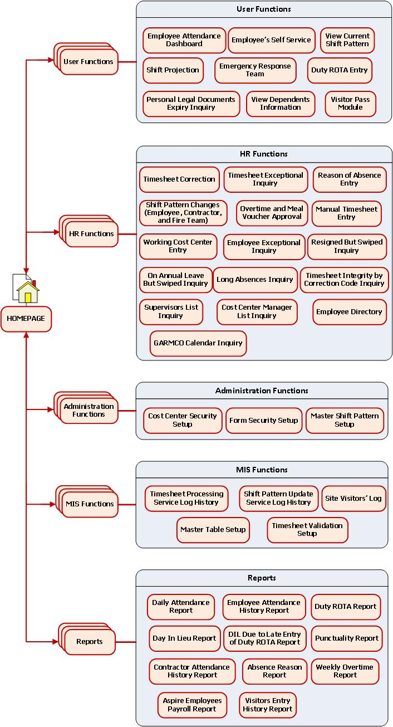Figure 2: Conceptual Site Map

## System Architecture

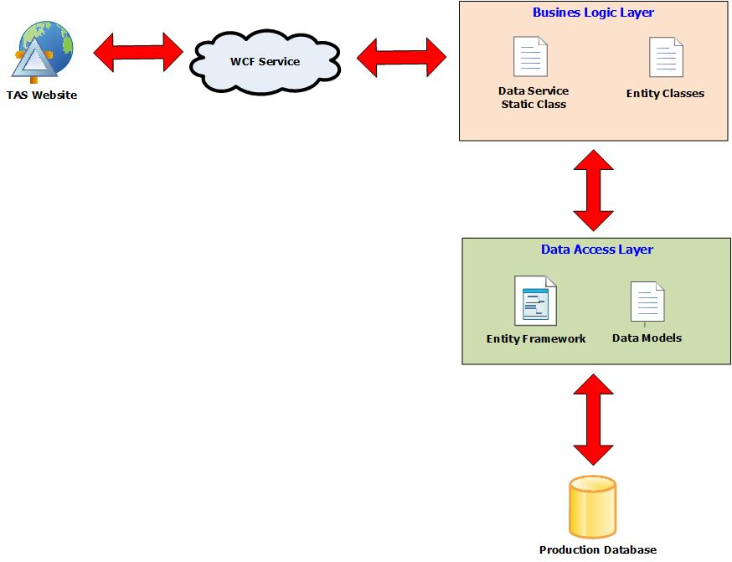Figure 3: System Architecture

# CHANGE MANAGEMENT PROCESS

Significant changes to the software requirements document shall be only be made when it is the consensus of the group that they are necessary and feasible. Any other changes after the approval will not be entertained but rather will be implemented on the next phase by sending an enhancement helpdesk request. This to make sure that development will not be interrupted and deadlines will be met.

# WEB FORMS

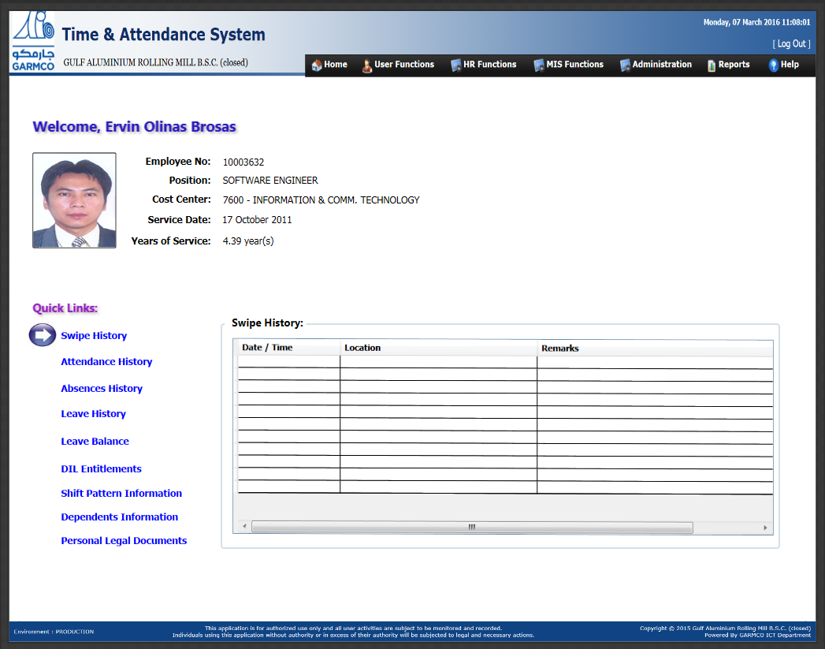 Figure 4: TAS Homepage